Answer of Final Examination of Software Engineering (A)
2004/06

Part 1 Selection ( 21 marks, 1 mark for each item)

- D
- A
- C
- B
- A
- C, B, A
- C, B
- C
- B, D, F, E. I
- A
- A, D, (E, F) / (F, E)

Part 2 Filling (20 marks, 2 marks for each item)

- data , actions
- (1 mark) Object-oriented
- ① lines of code ② function point
- ① operations ② methods
- (3 marks, 1 mark for each item) ① encapsulation ② inheritance ③ polymorphism
- ① execution-based testing ② nonexecution-based testing

Part 3 Judgment (9 marks, 1 mark for each item)

- T
- F
- T
- T
- F
- T
- T
- F
- F

Part 5 Case Analysis and Design (50 marks)
    - usecase diagram

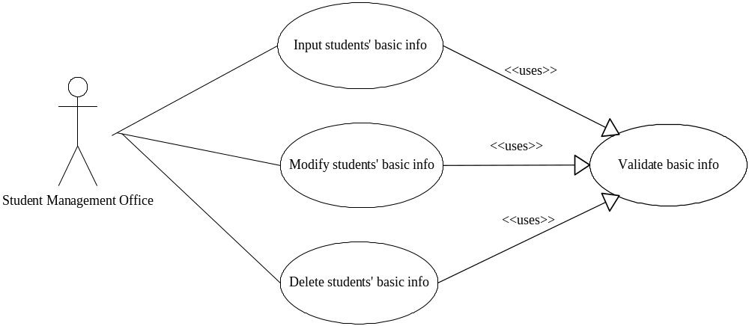
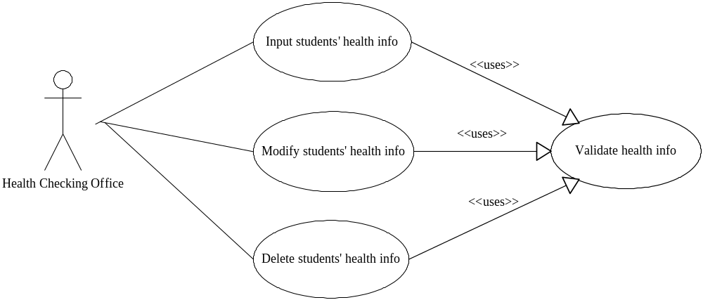
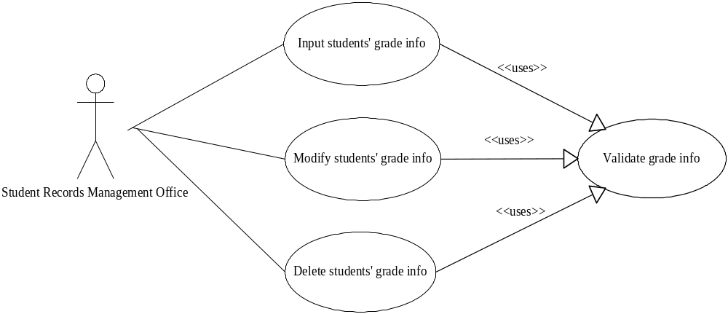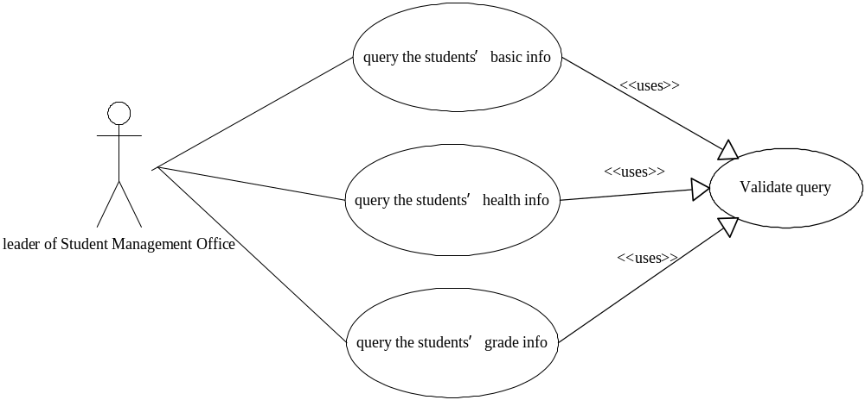

    - class diagram

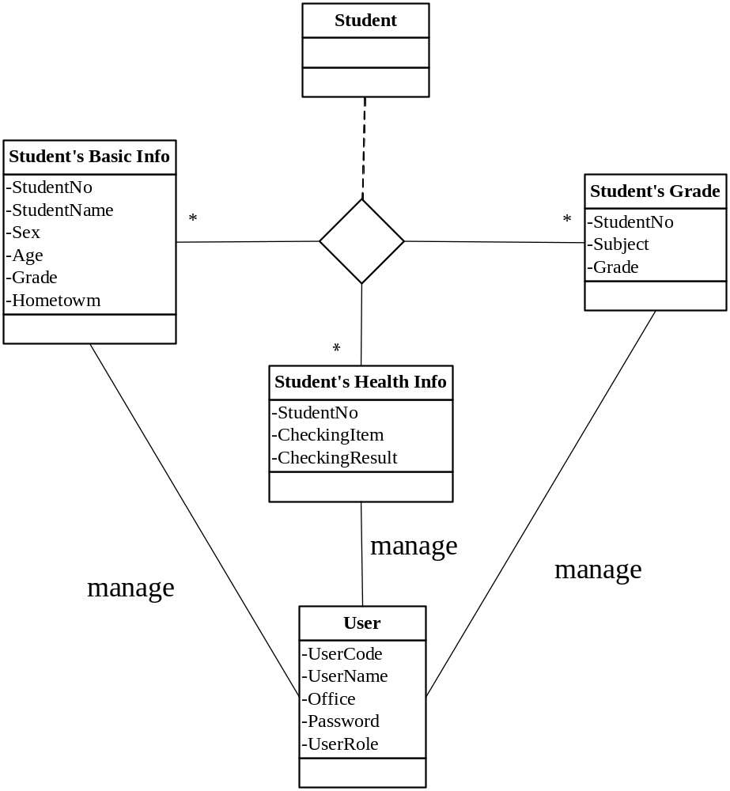

    - detailed class diagram
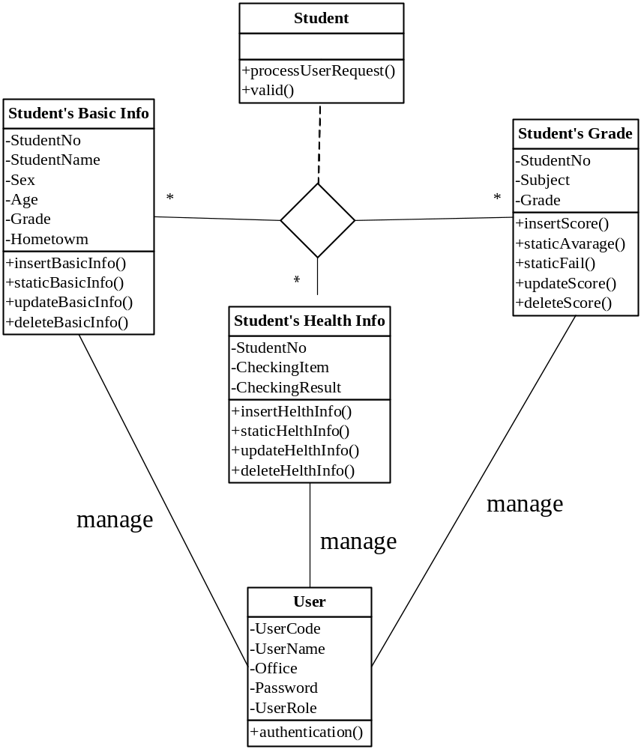

    - sequence diagram
